📄 YD-500CC2024 (500 pages)
🖼️ Product Overview
 Video: https://youtube.com/shorts/sXqm2iVywTA

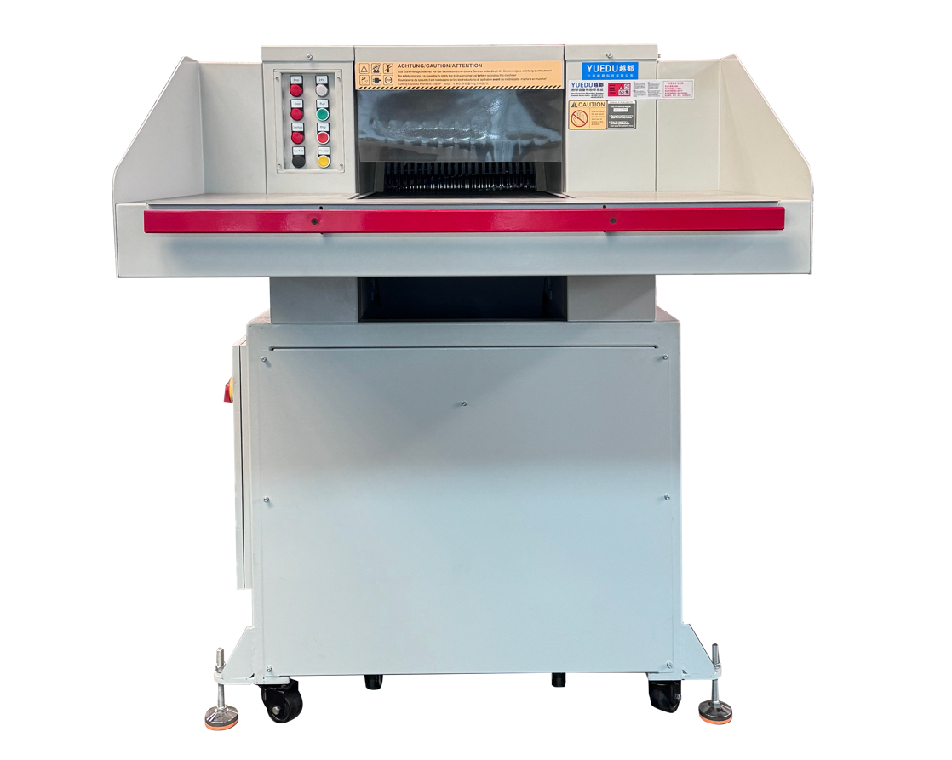
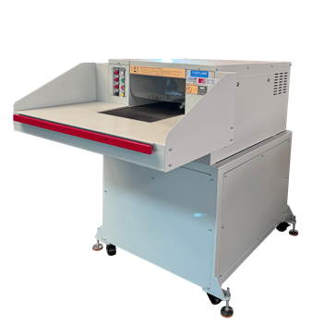 | 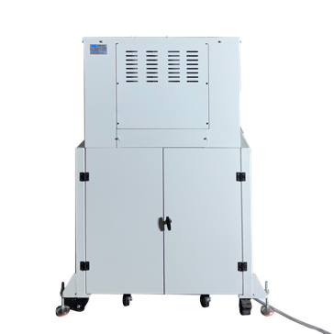 | 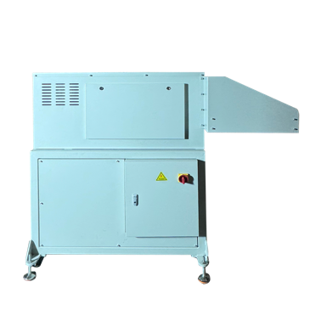 | 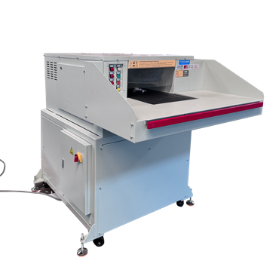
🔧 Technical Specifications：
🔒Security Level (DIN 66399) | P-2/O-2/T-2/E-2 | P-3/O-2/T-3/E-2 | P-4/O-3/T4/E-3 | P-5/O-4/T5/E-4/F-2
📥Feed Width (mm) | 500 | 500 | 500 | 500
✂️ Cut Size(mm) | 10.5x40-75 | 6x50 | 3.8x40 | 1.9x15
📑 Max Sheets | 500-550 | 340-380 | 180-200 | 90-100
⚖️Weight (kg) | 1200 | 1200 | 1200 | 1200
🔌Power | 7.5KW  3 x 400 V/50 Hz | 7.5KW  3 x 400 V/50 Hz | 7.5KW  3 x 400 V/50 Hz | 9.5KW  3 x 400 V/50 Hz
📏 L×W×H (mm) | 1318×1843×1638 | 1318×1843×1638 | 1318×1843×1638 | 1318×1843×1638
🗑️Bin(L) | 550L | 550L | 550L | 550L
💰Price (USD)
➕ Optional Add-ons:
Floor-mounted conveyor and rear baling system for efficient shredding and compact waste handling.

📄 YD-5002 Book Shredding & Baling Systems
🖼️ Product Overview
Video: https://youtube.com/shorts/NNEAbaoTO0g
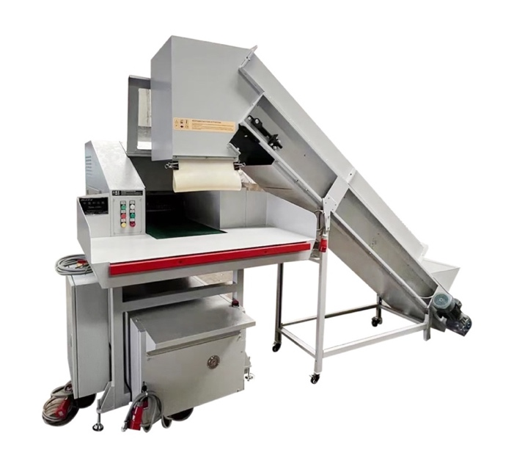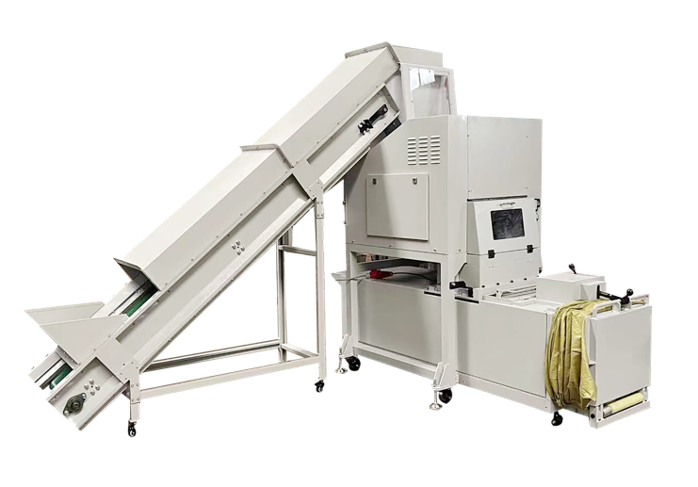
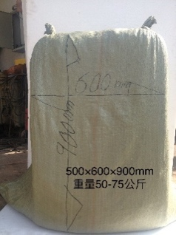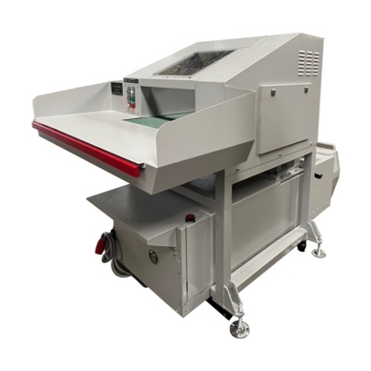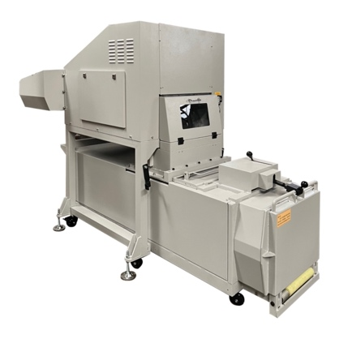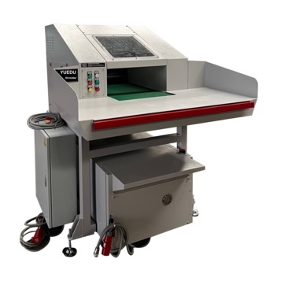
500CC shredder + 10T baler combo, ideal for secure rooms and archives.
Shreds up to 500 kg/h, compresses into 50–75 kg paper bales.
🔧 Technical Specifications：
⚙️Output/h: 500–600 kg
⚖️ Bale Weight: 50–75 kg
🧱Baling Pressure: 85 kN
🔌Power: 11.5 kW, 3 phase 400 V / 50 HZ
📏 L×W×H (mm): 3257*2588*2284
📐 System Overview: Three-View Diagram
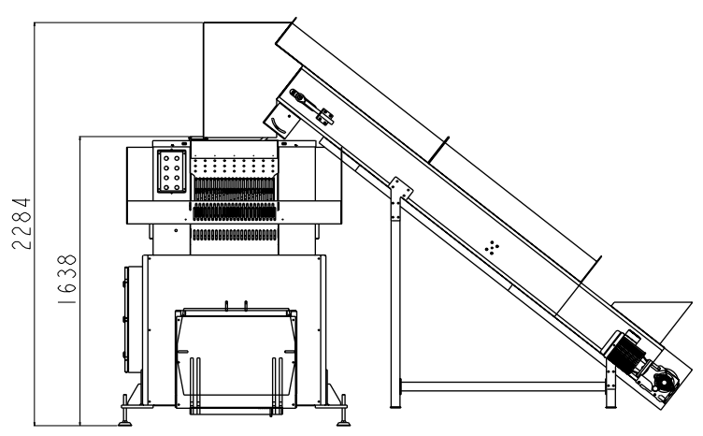 | 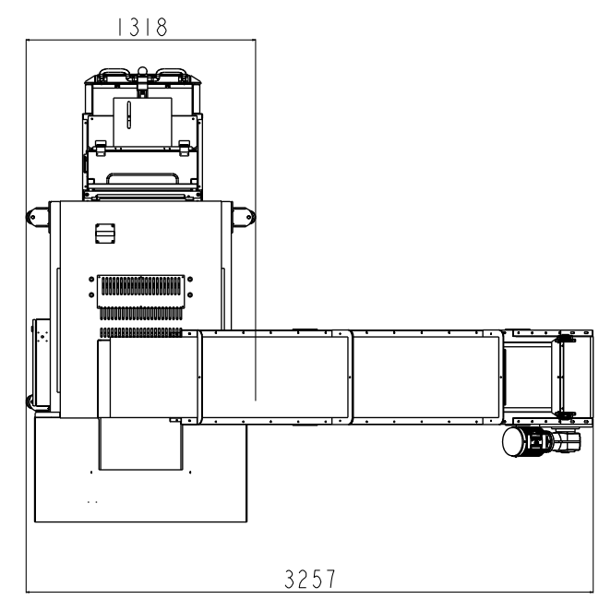 | 